CPR Broker test guide
Updated : 29 February 2012
Contents
Contents 2
1 Introduction 3
2 Unit tests 3
3 Client test application 3
4 Demo application 4

Introduction
This document describes the possible ways to test CPR Broker implementation for E&M database.

Unit tests
The E&M implementation of CPR broker has been thoroughly tested using unit tests. The tests were based on the NUnit framework, and they cover almost every aspect of the E&M code.
The unit tests have been put into the E_M.Tests project (CprBroker.Tests.E_M.exe). It is available in the project source code under Source\CprBroker\E_M.Tests.
Please refer to the online user manual for NUnit at () for more details.
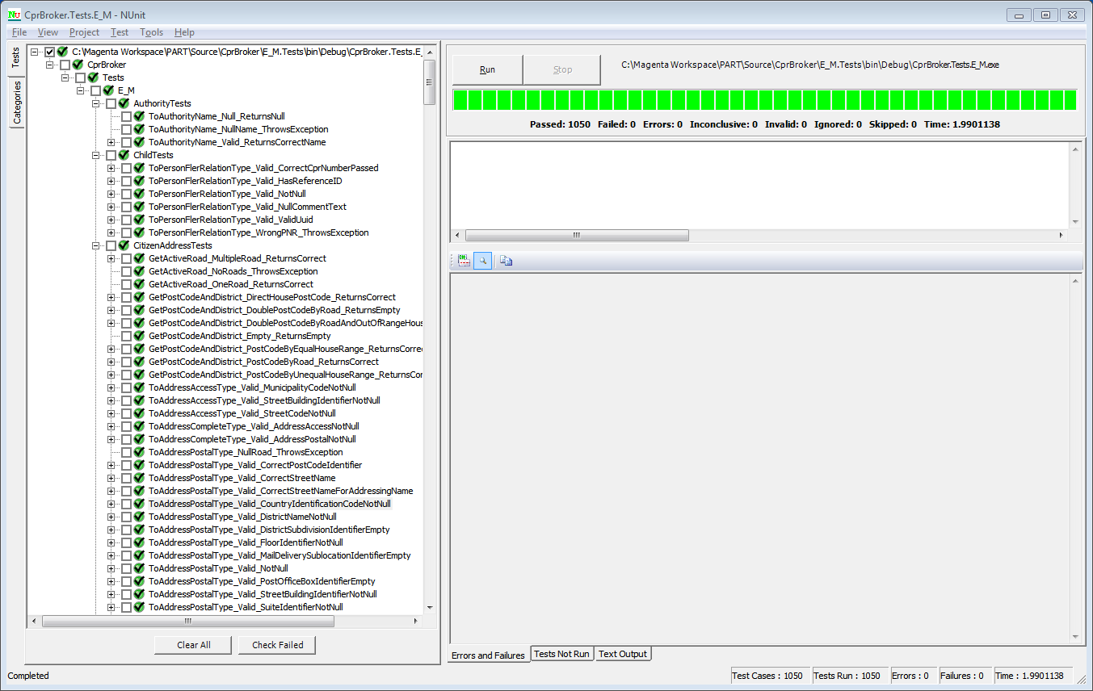

Client test application
Another method to test the application is to use the CprBroker.Tests.E_M.exe as a console application. The application will try to convert all the database records in the E&M database to PART standard, storing the xml to <working dir>\Runs\<current date and minute>\Registrations\.
The program takes the connection string as a parameter like this
E_M.exe “Data Source=<server>;Initial Catalog=<e&m databasename>;Integrated Security=SSPI”
By default, the app will try to use the Part.asmx service available at : http://CprBroker/Services/Part.asmx
And will use the application token fb6e6e79-7505-4667-9736-d500092d844b (belonging to an application registered as a test app)

Demo application
Another way to test the implementation is to use the demo application. The demo application was created with the original version of the PART standard implementation in CPR Broker.
The demo application is located under Source\Demo.
Some screenshots and instructions are shown below

Initialization
This step is done only in the first time the demo application is run.
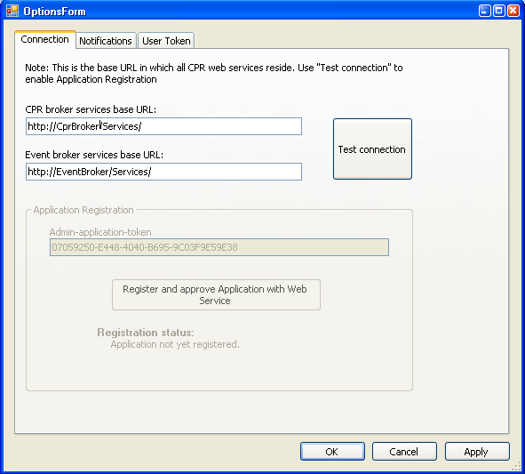
Verify the service URLs and press ‘Test Connection’.
Note
Please only specify the web folder path (as shown), not the actual asmx service URL
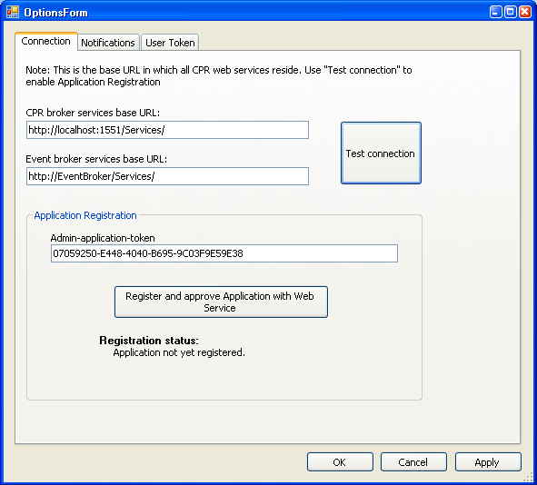
If you see the button ‘Register and approve …’ , press it to create a new application for the demo.
Then Press OK

Notification
To be able to test subscriptions, please enter a valid channel details on the Notifications tab. The channel will be passed whenever you try to create a new subscription.
Easiest thing is to use a preexisting folder. This means that new notifications will be created as XML file in that folder.
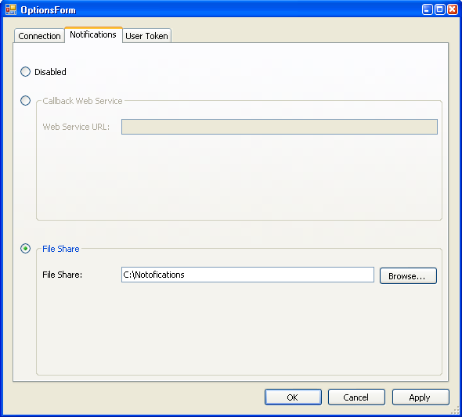

Using the demo app

Person data
Enter a CPR number and press ‘Look up CPR no’. This will call the GetUuid() method and the result will be shown.
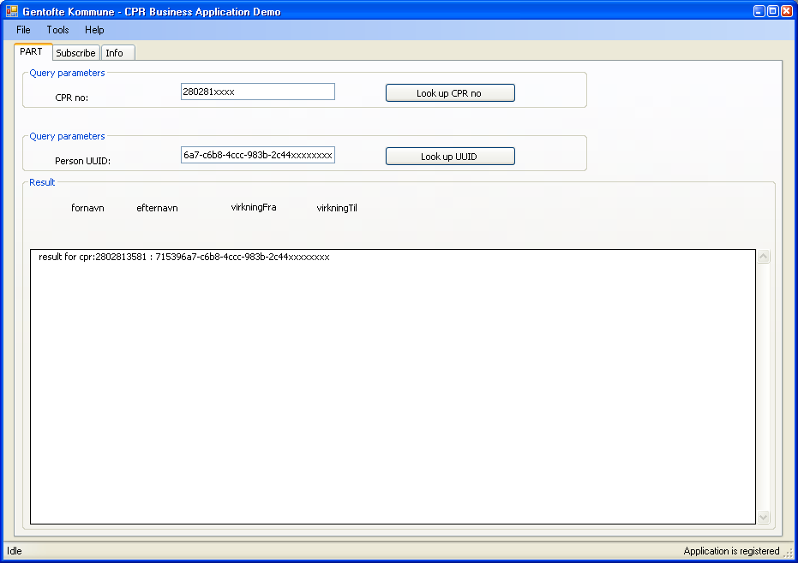
Now press ‘Look up UUID’. You should see the result XML response below
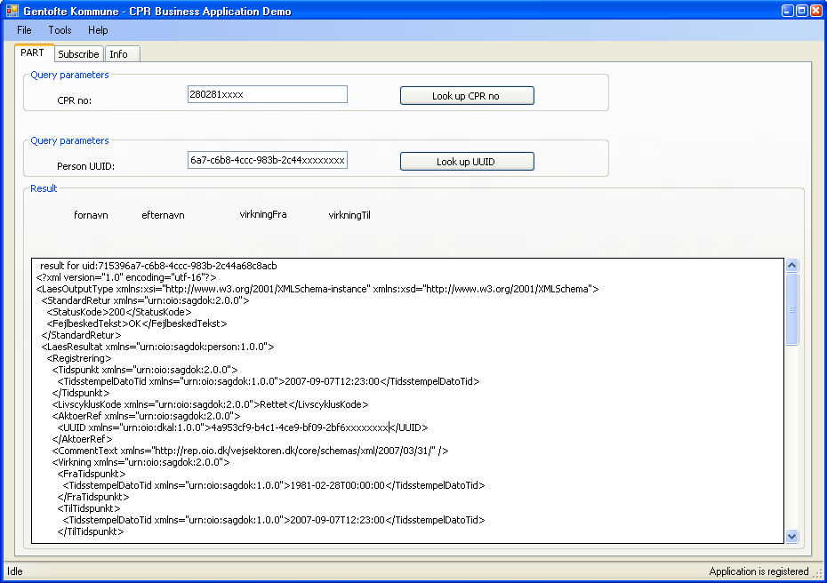
Verify the outcome XML. If you know that person, check the data (name, address,…etc)

Subscriptions
Now open the Subscribe tab.
Use the UUID you obtained previously as input, and then press one of the two ‘Subscribe’ buttons.
The first button will call the Subscribe() method. The second button will call SubscribeOnBirthdate() method.
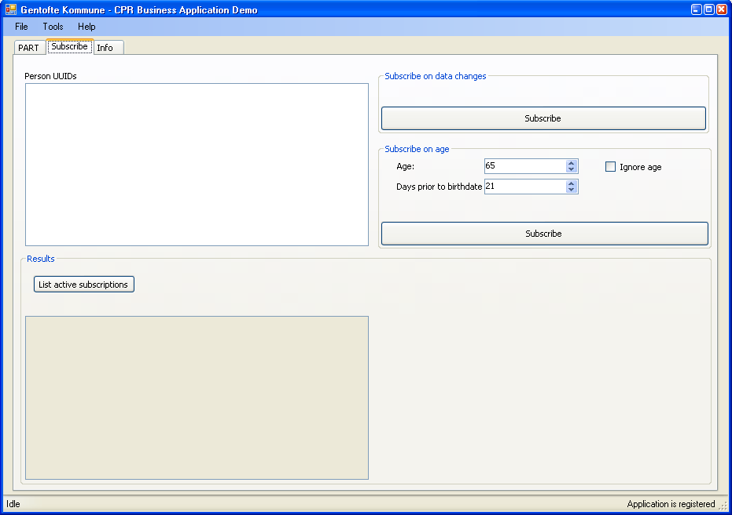
You should see the result in the box at the bottom.

